**Mobile App CSCS468**

**Ecommerce Website Report**

Muhammad Rehan Wali

Roll No: 241546596

Syed Murtaza Raza

Roll No: 241553242

**Introduction:**

The introduction of the mobile eCommerce application project outlines its purpose, emphasizing its significance in addressing current market needs. The objectives, target audience, key features, and technological stack are briefly introduced, setting the stage for the report's exploration of development processes and expected outcomes.

**Objective:**

The objective of the eCommerce website designed for today's females is to create a user-friendly platform that caters to their specific needs and preferences. This includes offering a diverse range of products, implementing intuitive navigation, fostering a visually appealing and empowering shopping experience, and ultimately establishing the brand as a go-to destination for contemporary women's lifestyle and fashion needs.

**Problem Statement:**

"In the fast-changing digital world, there's a problem with many online shopping sites. They don't always understand what people want. Some sites don't have enough products, are hard to use, or just don't make users feel good while shopping. This project aims to fix these issues by creating a special website that meets the unique needs of users when they shop online."

**Literature Review:**

The literature review aims to provide an overview of existing research and insights related to mobile eCommerce applications, user experience, and technology trends. This comprehensive review informs the development of a specialized eCommerce website designed for a contemporary audience.

**Mobile E-commerce trends:**

With an increasing number of users accessing eCommerce platforms via mobile devices, businesses are adopting a mobile-first approach to design and development. AR and VR technologies enhance the online shopping experience by allowing users to visualize products in a real-world context before making a purchase. AI-driven algorithms are used to analyze user behavior, providing personalized recommendations and a more tailored shopping experience. The adoption of mobile wallets and contactless payment methods for faster and more convenient transactions.

**User Experience in eCommerce:**

Ensuring that the navigation throughout the application is straightforward and user-friendly. Users should easily find the products or services they are looking for without unnecessary complexity. Adopting a clean and minimalistic design that reduces clutter and focuses on the essential elements. This can enhance visual appeal and make the user interface more intuitive. Maintain consistent branding elements such as colors, fonts, and imagery to reinforce the brand identity. Consistency helps in building recognition and trust among users. Simplify the checkout process to minimize friction. Consider implementing a one-click checkout option and provide clear steps for users to follow, reducing the likelihood of cart abandonment.

**Technologies Used:**

By leveraging this technology stack, the eCommerce application combines the power of React Native for dynamic client-side functionality, Figma for collaborative UX/UI design, and SQL for robust and structured database management. The synergy between these technologies aims to deliver a seamless and visually appealing user experience while ensuring data integrity and efficient backend operations.

**Case studies and success stories:**

Amazon is a perennial example of eCommerce success. The company's innovative strategies, customer-centric approach, and continuous expansion into new markets have made it a benchmark for eCommerce excellence. Alibaba, particularly in its home market of China, has transformed eCommerce with its comprehensive ecosystem, including online marketplaces, cloud services, and financial products. Shopify has gained prominence as a leading eCommerce platform, enabling businesses of all sizes to set up and run online stores. Its success lies in providing a user-friendly platform with a range of customizable features. Lululemon, known for its activewear, successfully expanded its eCommerce presence by combining quality products with a strong online community and personalized shopping experiences.

**Designs:**

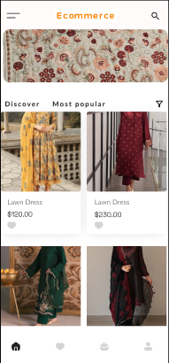

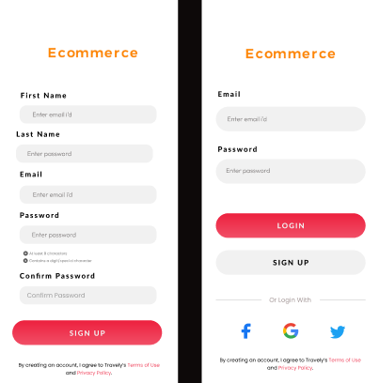

**System Architecture:**

**System Architecture Overview:**

The architecture of our eCommerce application is designed to deliver a seamless and intuitive user experience by leveraging React Native for the client-side, SQL for the database, and Figma for UX/UI design. This approach ensures a responsive, cross-platform application with a robust backend and an engaging visual interface.

**Client-Side Architecture with React Native:**

React Native serves as the core framework for developing the client-side of our application. This JavaScript-based framework enables the creation of native-like mobile applications for both iOS and Android platforms. React Native's component-based architecture allows for modular development, facilitating code reuse and a consistent user interface across devices. React Native's also focuses on building responsive user interfaces ensures a smooth and engaging shopping experience for users.

**Database Architecture with MongoDB:**

MongoDB serves as the backbone of our eCommerce application, providing a flexible and scalable NoSQL database solution. MongoDB's document-oriented nature is well-suited for handling diverse data types and accommodating the dynamic requirements of an eCommerce platform. MongoDB employs a document-oriented data model, where data is stored in BSON (Binary JSON) format. This document structure allows for the representation of complex relationships and nested data, which is advantageous for an eCommerce application dealing with diverse product categories and attributes.

**UX/UI Design with Figma:**

Figma plays a crucial role in the design phase, providing a collaborative platform for UX/UI design. Designers use Figma to create visually appealing interfaces and prototypes that align with user preferences and industry trends. Collaborative Design Environment: Figma allows designers, developers, and other stakeholders to collaborate in real-time, streamlining the design iteration process. Prototyping Features, Figma's prototyping features enable the visualization of the application's flow and layout before development, facilitating a user-centered design approach. Consistency Across Platforms, Designs created in Figma ensure consistency across various devices and screen sizes, contributing to a unified brand experience for users.

**Test Case:**

**Test Case 1:** User Registration

Input: Valid user details (name, email, password)

Expected Outcome: User is successfully registered and redirected to the login page.

**Test Case 2:** User Login

Input: Valid login credentials (email, password)

Expected Outcome: User is successfully logged in and redirected to the dashboard.

**Test Case 3:** Incorrect Login

Input: Invalid login credentials

Expected Outcome: System displays an error message and does not allow login.

**Test Case 4:** Password Recovery

Input: User requests a password reset

Expected Outcome: Password reset link is sent to the user's email.

2. Product Management:

**Test Case 5:** Product Search

Input: User enters a keyword in the search bar

Expected Outcome: Relevant products are displayed matching the search criteria.

**Test Case 6:** Product Details

Input: User clicks on a product to view details

Expected Outcome: Product details page displays accurate information (price, description, images).

**Test Case 7:** Add to Cart

Input: User adds a product to the shopping cart

Expected Outcome: Shopping cart reflects the added product with correct quantity and total price.

**3. Shopping Cart:**

**Test Case 8:** View and Edit Cart

Input: User navigates to the shopping cart

Expected Outcome: Cart displays all selected items; user can edit quantities or remove items.

**Test Case 9:** Checkout Process

Input: User proceeds to checkout

Expected Outcome: Smooth checkout process with options for payment and order confirmation.

**4. Payment Processing:**

**Test Case 10:** Successful Payment

Input: User completes the payment process

Expected Outcome: Payment is successful; user receives an order confirmation.

**Test Case 11:** Failed Payment

Input: User attempts a payment with invalid details

Expected Outcome: System displays an appropriate error message; order is not processed.

**5. User Account Management:**

**Test Case 12:** Update Account Information

Input: User updates profile information

Expected Outcome: User information is updated in the system.

**Test Case 13:** View Order History

Input: User checks order history

Expected Outcome: User can view a list of past orders with relevant details.

**Conclusions:**

The report establishes a foundation for our eCommerce application project, offering insights from diverse perspectives in mobile commerce, user experience, and technology. By synthesizing these findings, we aim to create a robust and user-centric platform that addresses current challenges and aligns with emerging trends in the eCommerce landscape.